History in the Making

The beginning….
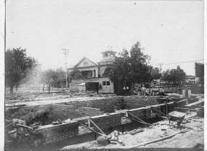
Looking Southwest on Park Street, the First Methodist Church is in the background
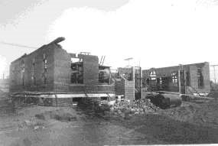
Erecting the brick walls
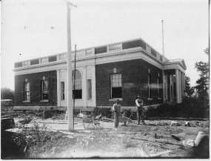
Completed in 1918 and served as the post office until 1971

In July, 1917, the ground was broken for the construction of a new U.S. Post Office in Commerce. It was built by the United States Department of Treasury for a cost of $45,000. The contractor for the building was Algernon Blair of Montgomery, Alabama. The building was to be ready for occupancy by March 2, 1918. There was a bit of a delay with that date because of late deliveries of material caused by “emergency work.” (Letter from Algernon Blair, Contractor) Since the United States was at war at that time, it can be supposed that the emergency work was related to the war. The actual date for the completion of the building was August 15, 1918 when it was declared ready for occupancy.
A description of the building appeared in the August 1918 Commerce Journal Illustrated Industrial Edition: “The building was constructed with outside walls of red shale brick laid in a Flemish Bond pattern. The windows had jack arches and inlaid keystones. There were two large modified Palladian type windows, one on the north side and one on the south. Light-colored sandstone was used for trim. The roof terrace was enclosed with parapet walls and balustrade panels. The front portico was of modified Tuscan order with four large painted wood columns.”
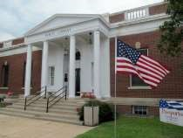

Transforming History
From Post Office to Library….
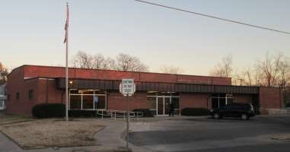
On April12, 1972 there was an Open House for a new Post Office Building in Commerce at 1300 Park Street. This new and modern $200,000 Post Office building had many advantages over the old one. There were 4,000 additional square feet of work space, and “snorkel” boxes made drive-in mailing convenient. Off-street parking, an enlarged vestibule about three times the size of the old one, a worker’s lounge with a coffee machine and space for cold drink machines were major improvements. Best of all, unlike the old building, the new post office had only one floor, with no stairs to climb. (Commerce Journal, December 2, 1971)

Meanwhile, the old post office building at 1210 Park Street stood empty, replaced by its more modern counterpart. The building had served Commerce as a post office from 1918 to 1971, when plans were announced that the building would be abandoned as a post office. The City of Commerce made application for the building to use as a public library. A Deed Without Warranty was awarded the City in March 1972. The value of the building at the time was set at $31,500 but a public benefit allowance for the entire sum was granted because the building was to be used as a library.
(Texas Almanac, 1984-85; Hunt County, Texas, Deed Without Warranty recorded in County Clerk’s Office)
Renovation of the building was done by the City at a cost of $15,000. Care was taken during renovation to preserve special architectural features. No outside changes to the building were made and only those inside which were necessary to accommodate library functions. Even the black marble baseboards in the front lobby were retained when the mail boxes were removed.
(Greenville Herald Banner, September 1973)
The Library moved into the building on March 23, 1973. All spaces of the main floor, full basement, and partial second floor were converted to various library usages. In 1976 a small partially-enclosed loading dock on the east side of the building was completely enclosed and a space of 200 square feet was added to the useable space for the library. Air conditioning was installed in a second room in the basement in 1987.
(Letter from Roy W. Washam to Ms. Opal Williams, October 7, 1975; minutes of Commerce Public Library, February 3, 1987)
The building, after having served as a post office for forty-five years, now serves as a public library for the citizens of Commerce and surrounding areas.

Recognizing History:

Commerce Public Library Historical Marker
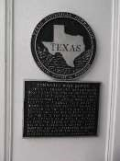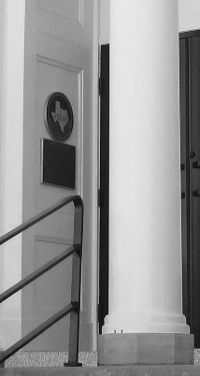

On November 17, 1991, in downtown Commerce, the building at 1210 Park Street, which has housed the Commerce Public Library since 1973, was commemorated in a special ceremony. A Texas Historical Marker plaque was unveiled at the entrance of the library, which was once the site of the Commerce Post office.
The marker reads: “Commerce Post office: The U.S. Treasury Department began construction of this building in July 1917, during the country’s involvement in World War I. Completed in August 1918 after a number of construction delays, it served as the city’s main post office facility until 1971. Deeded to the City the following year, it reopened as a public library in 1973.
The Georgian Revival-style building features a central entry portico and an alternating parapet/balustrade along the roofline. Recorded Texas historic Landmark – 1991.”

The ceremony included brief remarks by Commerce City officials, members of the Public
Library board and leaders of the Friends of the Library. Carol Taylor, chairman of the Hunt County Historical Commission, presided over the ceremony. City of Commerce Commission members at the time were Mr. J.H. Teel, mayor, Mr. David Ayers, Mr. Charley Jones, Mr. Bob Monday, and Mr. Ivory Moore. Much of the research to apply for the marker was accomplished by Dorothy Wood Moore, and Maude Johnson.
Arthur West, a longtime Friends of the Library and Library board member, performed the unveiling of the marker. Arthur West was Commerce Postmaster from 1960-1961 and was president of the Library Board from 1964 to 1986. Eugene Wall, who was a Commerce post office employee from 1953 to 1978 and Commerce Postmaster from 1978 to 1988 also addressed the group with a short history of the local postal facility.
Dr. John McQuary, President of the Library Board was present at the dedication of the marker. David Gibson, Minister of the Church of Christ, Commerce gave the invocation and Steven Goughnour, Minister of First Christian Church, Commerce, gave the benediction.
This event reminds us of the importance of the building to the history of Commerce. The group that worked to obtain the historical marker did their part to recognize the importance of this historical building constructed between 1917 and 1918.

Restoring History: Portico Restoration

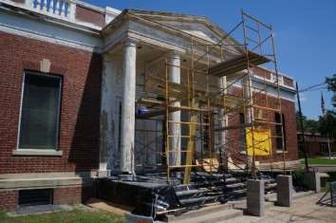
The Commerce Public Library has inhabited the historical former post office building at 1210 Park Street in downtown Commerce since 1973. Before the library moved into the building, the city of Commerce allocated funds for modifications so that it would be suitable for a library. The city also allocated money for furnishings. In June 1980, the City of Commerce passed Resolution No. 356, a working agreement between the City and the Friends of the Commerce Public Library to provide the building and insurance on the building, provide utilities and grounds maintenance, and maintain the following: the roof, paint (inside and out), air conditioning equipment, hot water radiator system, hot water system including the boiler, and water and sewer pipes.
Since that time, little was done to maintain the exterior of the building and city resources fell short when the roof began to leak and the air conditioning equipment failed. In the summer of
2011, with 90 degree temperatures inside the building because of a failing air conditioning system, the
Friends were told by the city that there were no funds to replace or repair it. In March, 2012, the Friends began a campaign to “Save the Library!”
The first action toward the goal was a work day held in April, 2012. Volunteers who arrived that morning were students from the Honors College at the university as well as university faculty and library board members. Efforts were focused on outside clean-up and the removal of plants encroaching on the building foundation and adversely affecting drainage. A rickety bench was removed and the bicycle rack and railing re-painted. Inside the building cleanup continued and the preparation of the walls for painting was planned.
The activity at the Library caught the interest of a passer-by. He stopped to investigate and became involved in the discussions about the renovation. Since he had considerable experience in historical restorations, his input was of special interest to the library board members present that day. He was later to become very involved with the renovation when he was contracted by the Library Board to restore the portico. Evidence of his contribution is very visible in the transformation of the entrance to the building. His continued involvement has included renovation of the Story Time/ meeting room, repair of the ceiling in the passport area and finally fixing a persistent ceiling leak that defied explanation. Mike Hudson, local contractor, will continue to be a key player in the coming parapet restoration project. It is hoped that he will begin the parapet restoration within the next few weeks.
Following the work-day In May of 2012, a series of Town Hall meetings were held to address the problem of the deteriorating building. The “Save the Library” campaign to restore the historical building resulted in the formation of a steering committee charged with raising money for the restoration. Before the committee began work, a major setback in the form of a 25% decrease in city funding left the Friends of the Commerce Public Library Board wondering about the future of the library. The committee was disbanded and the renovation was put on hold with the exception of funds from the First Methodist Church Foundation which were used to replace the non-functioning air-conditioning.
Approximately $7,000 remained in the renovation fund after the Town Hall meetings. In June 2013 the Friends decided to use the funds to restore the portico of the building. The portico was chosen since the roof was considered stable and since it would have the greatest impact on the overall appearance of the building. The Library contracted with Mike Hudson, with his considerable experience in historical renovations, to restore the portico. Mike undertook the painstaking and labor-intensive effort of stripping, scraping and sanding away decades of old paint in late June. He repaired and replaced decayed and damaged wood with new materials to match the original cypress woodwork. His work included the daunting restoration of the four classical Tuscan columns at the West Portico which form the main entrance to the Library. These wood columns have served since 1917 but were beginning to show consideration deterioration. The columns were fabricated using a number of wood slats jointed with tongue and groove construction and glued to form a hollow drum. The glue joints were beginning to come apart allowing moisture to penetrate the columns and contributing to further splitting and rotting. During the restoration, stabilization of the columns was accomplished and the beauty of the portico was restored. The work was completed in mid-August, 2013.

Restoring History: Parapet Project
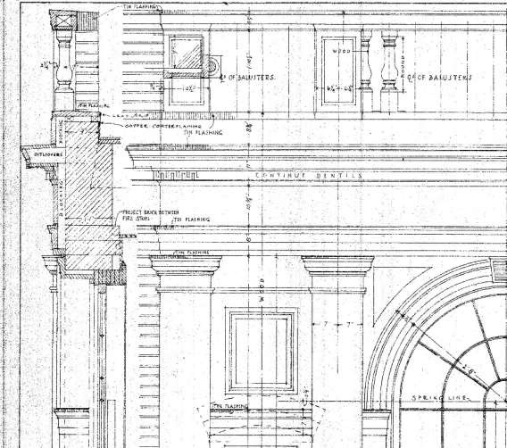

As seen in the above architectural drawing from 1917, the parapet is not just made up of spindles (balusters) but a combination of cypress wood trim, flashing, blocking, dentil molding, and brick sections making up the crown of the building as well as the cornice work beneath the parapet.

The parapet wall was selected as the next project to be tackled after the 2013 restoration of the portico of the building. One reason for the choice was because of its very visible deterioration in contrast to the beautiful portico. Another reason, not so noticeable, was because of the continuing small but persistent leaking into the building even after the city-funded roof replacement in 2014. A contractor, while repairing ceiling damage in part of the building, found leaking related to the parapet wall. That leak was repaired but others are likely to be found. It is important that the interior of the building be leak-free before the much-needed repair and renovation inside begins. As the wall is restored, the integrity of the roof will be ensured.

The Library building is a Recorded Texas historic Landmark designated by the Texas Historical Commission in 1991. To preserve that designation, it is advisable that before a project is begun, it be reviewed by the Commission. A proposal to restore and rehabilitate the existing historic parapet and cornice line was sent for review. In late June, 2017, the Commission review staff sent a letter of approval for the project stating that “the Staff commends the Commerce Public Library on gathering together the historic documentation and a qualified project professional to ensure the accuracy of the restoration and rehabilitation effort. The staff would like to acknowledge that much of the existing carpentry may be repaired and preserved in place rather than replaced. After scraping the existing failing paint, wood epoxy/consolidate should be applied to strengthen those salvageable carpentry elements before sanding and repainting. All fully deteriorated wood can be removed and replaced with in-kind matching material. The project meets the Secretary of Interior’s Standards for Rehabilitation and Restoration. The staff hereby confirms that…work may proceed without further consultation with our office.”

With this approval, on Monday, July 1st, Mike Hudson began work on the parapet restoration project with the removal of the spindles. He evaluated each spindle for soundness and restored those that were salvageable offsite. One hundred and three new cypress wood spindles, duplicates of one of the originals, were ordered to replace those too deteriorated to be restored.

Onsite he then selectively disassembled a section of parapet, removing damaged or deteriorated elements like the cap flashing (the metal on top of the wall), and rotted moldings. Whatever remained was stripped to remove all old lead paint. Next, new matching materials were installed to replace the damaged elements removed earlier, including new moldings, flashings and, of course, the spindles, both new and restored. When everything was back in position, all the components were painted and caulked to finish the job.

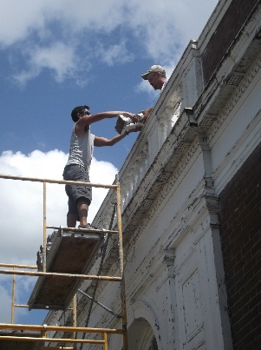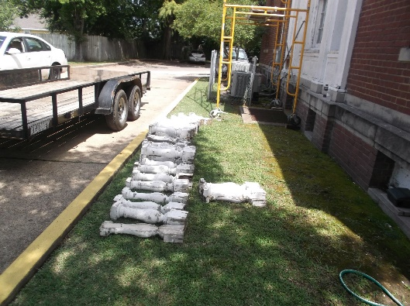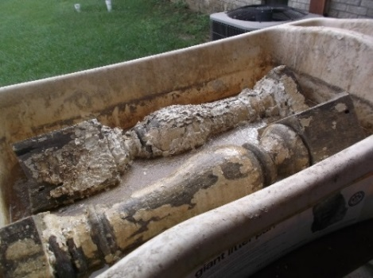

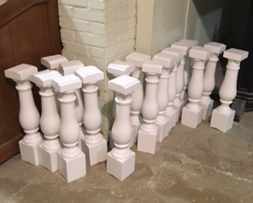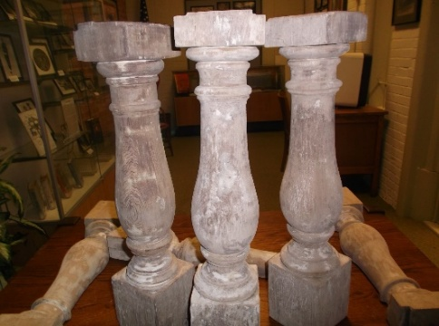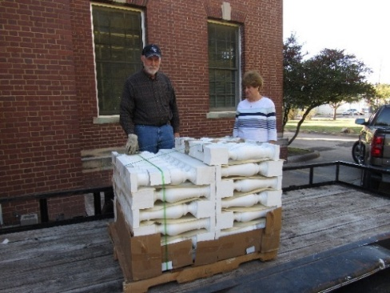

While not part of the parapet, the Palladian windows, one on the south and another on the north side of the building, are among the most beautiful features of the historical structure. Rescuing them from further deterioration is the logical next step in the exterior restoration.
Progress toward the complete restoration of the windows happened in an unexpected way. A local artist, David Zvanut, MFA, was creating a large fused-glass art piece to install inside the window on the south side of the building. Interior lighting makes it viewable from both inside and outside at all times. The window depicts a Bois d’ Arc tree in autumn, a subject appropriate for the city recognized as the Bois d’ arc Capitol of Texas and home of the annual Bois d’ arc Bash. The Hunt County Public Art group funded the art and covered the cost of the restoration of the window before the installation of the art work.
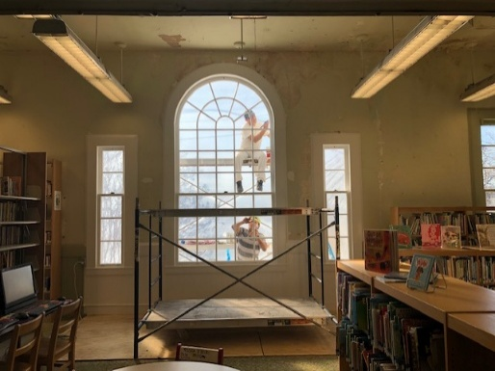

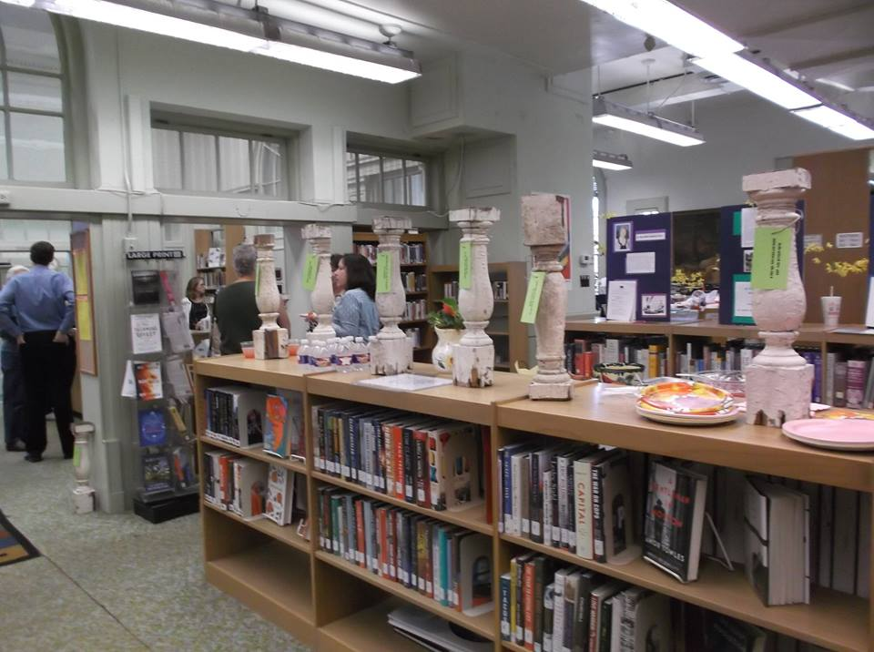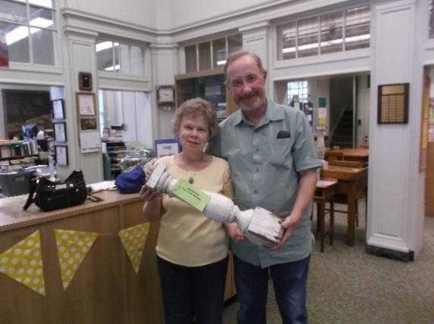

Alphabetical list of Spindle Donors:

Bill Abernathy in memory of Mr. and Mrs. D.C. Abernathy, Jr.
Debbie Aikin - Donation toward spindle in honor of Harriet and Wyman Williams’ 50th Anniversary
Altrusa International Club of Greenville in honor of Literacy
Dennis and Judy Anderson - Donation toward spindle in honor of Harriet and Wyman Williams’ 50th Anniversary
Earl & Susan Andresen
Anonymous – two donors requested to be anonymous
Jim & Teena Ayres, Commerce Funeral Home and Cremation
Andrew & Shannon Baker
Mr. and Mrs. David S. Barera in honor of The Barera Family
David & Monika Barera in honor of son Michael Barera
Michael Barera in honor of Frank von Neuhaus
Kaye Beth – 4 spindles in memory of Dr. H.P. Credille, Willie Reno Credille, Bessie M. Credille, Alice Hamilton Credille
Fred & Anna Blohm
Carolyn Burt – Donation toward DAR spindle
Captain Charles Croxall Chapter of the National Society of the Daughters of the American Revolution and the Texas DAR (Individual donors listed separately)
Nelda Carter – Donation toward DAR spindle
Betsy Chapman – in memory of Linnie Atchley by her niece, Betsy Robinson Chapman
Mike & Nan Clay
Colonial Lodge of Greenville
Commerce Lion’s Club – three spindles
Jane Cox – in memory of Joe Fred Cox and in honor of Karen Jo Cox
Jerry Davies
Jerry & Vicki Davis – in honor of Jerry, Vicki, Jay Davis
Vicki Davis - Donation toward DAR spindle
Delphian Club
Scott & Diane Downing
Dough Rollins Sunday School Class, First United Methodist Church - Donation
Wendell & Linda Edwards – Donation
Lindsey Ewert in memory of Mary Elizabeth Channon
Jennifer Garrett
Bob & Sally Grove – 2 spindles + additional donations
Rebecca Hair – Donation toward DAR spindle
Jenny Hanby in memory of F.H. (Bub) McDowell
John and Mary Hardy - Donation toward spindle in honor of Harriet and Wyman Williams’ 50th Anniversary
Jeff Helton in honor of his wife, Jan, for Mother’s Day 2017
Kent & Jency Holbert
William & Dorothy Hopkins
Steve and Mary Humphrey – Donation in memory of Gayle Shumate
Rheba Icenhower
Dolores Jackson – Donation toward DAR spindle
Paul & Norma Johnson
Rohith Kumar Kadari in honor of Rick Miller
Jerry & Theta Keeble
Michael G. Kelley – 11 spindles in honor of Margret Guthrie Kelley, W.L. “Woody” Kelly, Time Kelley, Pat Kelley, Donna Kelley, Regan Kelley, Jason Keyes, Chris Kelley, Matt Kelley, and Jennifer Nunez
Barbara Kersey in memory of Frances A. Thompson
Loretta Kibler in honor of Dr. Marc McDaniel
Ravelle Rainey Kundinger in honor of the Rainey Family
Susan Lampe
Susan Lampe - Donation toward spindle in honor of Harriet and Wyman Williams’ 50th Anniversary
Jim Bob and Janet Latham - Donation toward spindle in honor of Harriet and Wyman Williams’ 50th Anniversary
Dick & Brenda Latson in honor of the Latson Family
Gene & Carolyn Lockhart
Joyce McCord in memory of Kenneth McCord
Diane McDowell
Keith & Nancy McFarland
Richard & Mary Miller
Joe and Laura Milligan - Donation toward spindle in honor of Harriet and Wyman Williams’ 50th Anniversary
Anne Mills – Donation toward spindle in honor of Harriet and Wyman Williams’ 50th Anniversary
Billie Mills
Bob & Norma Monday
Billy and Danna Myers - Donation toward spindle in honor of Harriet and Wyman Williams’ 50th Anniversary
Noah and Diana Nelson - Donation toward spindle in honor of Harriet and Wyman Williams’ 50th Anniversary
Dr. & Mrs. Srinivas Nippani - Donation
Michael & Donna Odom
Ilter Ozul
Jim and Susan Patton
Jim and Susan Patton - Donation toward spindle in honor of Harriet and Wyman Williams’ 50th Anniversary
Jack & Beverly Pirkey - 1 section (6) spindles
Jerry & Susan Pittman in memory of Gayle Shumate
Lonnie Plunkett in memory of Ethel and Jesse Stout
Bill & Sharon Prewett
Lee Riddle in memory of James R. Riddle
Michael & Angela Roberts
Mark & Frances Sartwell
Rick & Tina Fletcher Selvaggi in honor of Lily and Rose
Shell Oil Company Foundation – matching gift for C.H. Siebenhausen, Jr.
C.H. Siebenhausen, Jr. – two spindles
G.D. (Pat) Skauge
Janet Williams Skauge
John & Linnea Smith
John and Linnea Smith
Chad & Teresa Smith
Chad & Teresa Smith in honor of Eddie, Lynn, Allison and Nick Barker
Chad & Teresa Smith in honor Derych, Ruth, Makiah and Rose Gorman
Shirley Smith – Donation toward DAR spindle
Madeline Sullivan - donation
Jim Swart - Donation toward spindle in honor of Harriet and Wyman Williams’ 50th Anniversary
Annette Taggart - Donation toward spindle in honor of Harriet and Wyman Williams’ 50th Anniversary
Gary & Becky Thompson
Carolyn Trezevant
Carolyn Trezevant in honor of David and Luann Huffman
Carolyn Trezevant in honor of Judy Grau and Shadow
Robert W. Trezevant in honor of his sister, Carolyn Trezevant
Dixie Turman
Harry & Dora Wade
Tingxiu Wang, Liping Cai
Wyman & Harriet Williams
Wyman & Harriet Williams in memory of Linnie Atchley
Lauri Wiss - donation
Bobby & Neva Young
Paul & Sheryl Zelhart
Bettina & David Zvanut - donation
State Farm
Delphian Club
Diana Hines and group
Texas Historical Foundation
Lion's Club
Summerlee Foundation
Hunt County Public Art
Texas Historical Foundation
Psychology Club
Heartfelt Thanks to all of the above!

